**Project Idea: Sleep Tracker**

Description: Sleep Tracker can track the data of users’ room while sleeping. It can automatically record video or audio and turn on or off alarm according to sensors of possible factors such as light, pressure, or sounds, and it can also track users’ data and generate a report in a period of time. Still not sure about how far we should design and implement this, but still can be an idea.

Goal:

1. Record the time of sleeping
2. Combine movement and sound output to analyze deep sleep status

Email:

1. Minutes of meeting

2. Action items

**Demo:**

1. Recording Audio: Raspberry Pi can detect and analyze audio during users’ sleeping. In this step, one team member will simulate the environment of sleeping and speak some words, and the Pi can store the outputs for analyzing. (30%)

2. Detecting Movement: Raspberry Pi can detect and analyze movement when the user is sleeping. In this step, one team member will simulate the environment of sleeping and make some movements, then the Pi can store the outputs for analyzing. (30%)

3. Access Data: After sleeping, users can access all data, which will be presented in a chart with timestamps. In this step, one team member will open the web or application (depends on future design) and show different charts that reflect users’ sleeping quality. (40%)

**Sound Detection: check voltage**

<https://www.instructables.com/Sound-Sensor-Raspberry-Pi/>

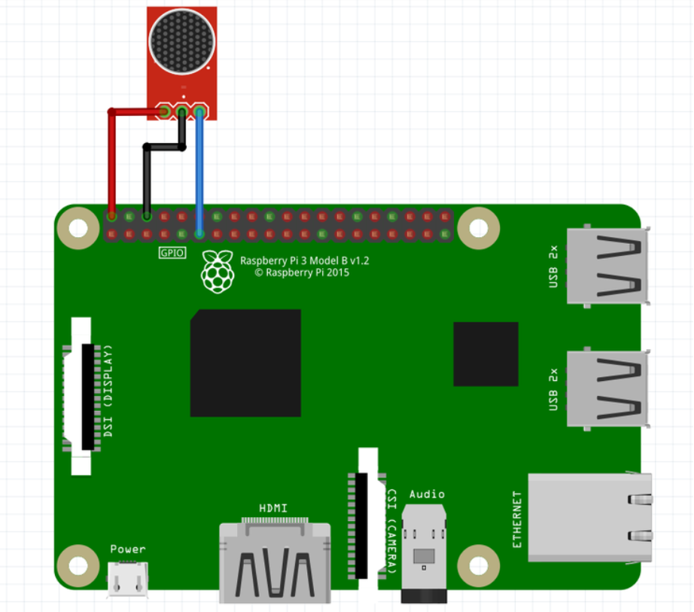

**Movement Sensor:**

The parent detector

<https://projects.raspberrypi.org/en/projects/parent-detector>

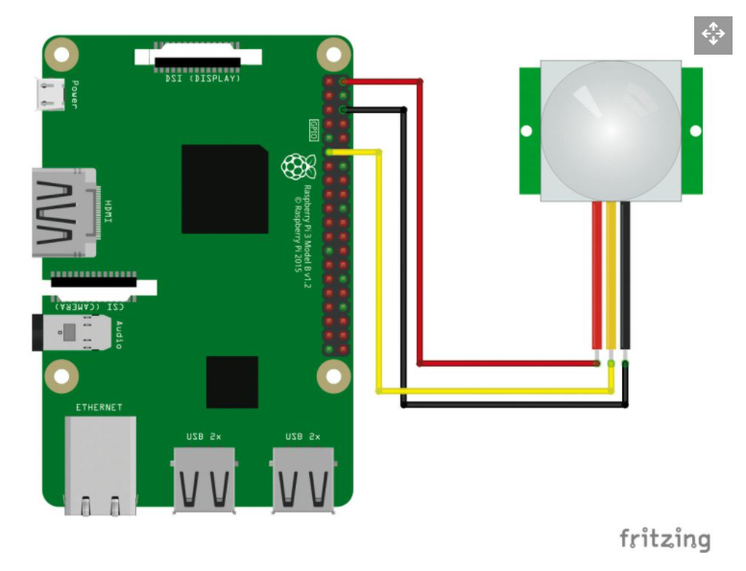

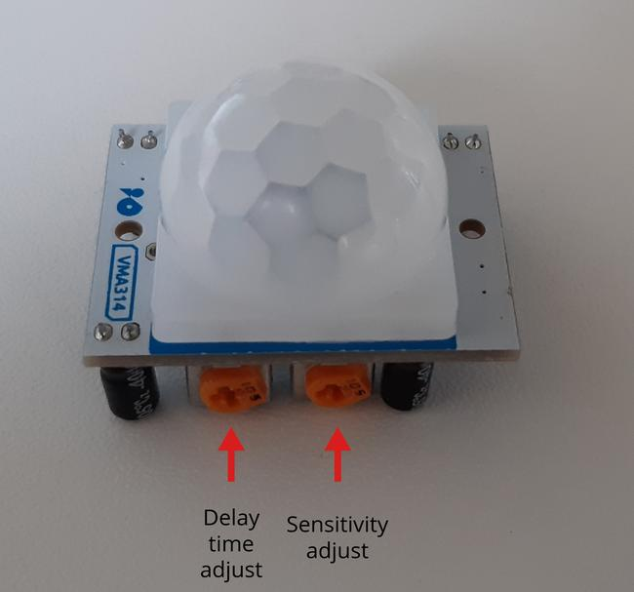

**Data storing:**

Homework Assignment 3 might be helpful for doing this part

Build Your Own Cloud Storage File Server With A Raspberry Pi

<https://learn.pi-supply.com/make/build-your-own-cloud-storage-file-server-with-a-raspberry-pi/>

**Project Possible resource:**

* Raspberry Pi Sleep Lab How-To

<https://www.appkabob.com/raspberry-pi-sleep-lab/>

* Walabot Sleep Tracker

<https://www.hackster.io/kuzma/walabot-sleep-tracker-472740>

* LittleSleeper: A baby sleep monitor using a Raspberry Pi and Python

<https://aicbt.com/raspberry-pi-sleep-monitor/>

* Create your own smart baby monitor with a RaspberryPi and Tensorflow

<https://towardsdatascience.com/create-your-own-smart-baby-monitor-with-a-raspberrypi-and-tensorflow-5b25713410ca>

**Project Possible Problem:**

* Connecting the circuit might need time to figure out
* Amplifying sensor’s data working with feedback of camera
* Figure out how to build web server that storing data

**Project Plan:**

* **4/5 - 4/9:** 
  + Connecting circuit to test different sensors
  + Figure out how to amplify data
* **4/12 - 4/16:**
  + Figure out how to connect all sensors’ circuits in a right way
  + Start build web server that stores all data, video, and audio files
* **4/19 - 4/23:**
  + Start testing and fixing bugs
  + Test the system following the demo’s order
* **4/26 - 4/30:**
  + Finish testing and work on report and documentation
  + Present

**Meeting Schedule**

Every Thursday 5 pm( <https://meet.google.com/qkv-phgq-yxg> )

· Determine different types of sleep based on the sounds and movements detected.

· Maybe have some type of distinctive sound to indicate that the user is awake???

· Use the audio as above a certain level for a certain time, the user was up and stuff.

· Use both the audio sensor and the movement sensor

· What is deep sleep?

· Show data of when the person was experiencing X types of sleep.

· Remove alarm.

· Focus on sleep monitoring.

· Meeting logs:

o Minutes of meeting

o What was done in the meeting

o Action steps of next meeting